The Haggard Herald 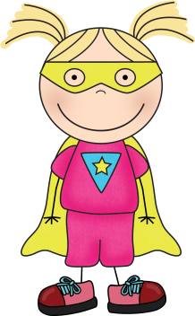
November 3, 2017

A Look Back At Our Month
In reading, the class identified nonfiction text features. They transformed headings into questions and used text evidence to help answer their questions. Students also used context clues to define new/unknown vocabulary while reading.
In writing, we discussed the meanings of the following words: there, their, and they’re. The class practiced placing the correct spellings of this word into sentences. In addition, we learned the steps of the writing process (prewriting, drafting, revising, editing, and publishing). Students wrote their own narrative stories. Then, they revised them by adding transition words and transformed ordinary words with vivid descriptions.
In math, the class learned how to build area models on their iPads before they uploaded their creations into Schoology. We made quick sketches on paper to show the partial products and totals of equations that contained two-digit by two-digit multiplication.
In social studies, students learned the states & capitals of the Midwest and Northeast regions of the United States. They chose a specific region and worked in small groups to research the geography, climate, products & natural resources, landmarks, and culture of that region.
Announcements:
Report Cards Go Home: 11/10/17
Parent/Teacher Conferences: 11/14/17 and 11/16/17 (Please look for your family’s scheduled conference time this week and let me know if it works for your family.)
No School-Thanksgiving Break: 11/23/17 and 11/24/17
No School: Teacher In-service 12/8/17
Holiday Concert: 12/21/17 (7 p.m. at the high school)

Visit Our Class Website: http://thaggard.weebly.com
Find classroom announcements, photos, and links to fabulous websites.

Don’t forget to visit our webpage for classroom pictures and cool links. http://thaggard.weebly.com

A Sneak Peak at November . . . Reading: Identify and use story elements, compare/contrast prose, poetry & plays
Spelling: Individual spelling words continue - Please practice sorts for 5 min. nightly (Mon.-Thurs.)
Writing: Continue changing past to present to future verb tenses, begin placing dialogue into stories with proper punctuation, begin writing/revising/editing own descriptive breakfast stories
Math: Wrap up multi-digit multiplication & early division unit, begin fraction/decimal unit
Social Studies: Create presentation slides on specific U.S. region to teach the rest of the class, learn/review the states & capitals of all 50 states

This is going to be a SUPER year!

