The Haggard Herald 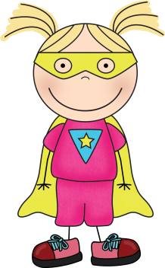
March 2, 2018

A Look Back At Our Month of February
In reading, the class found the main idea and supporting details before they summarized informational texts. Students determined the author’s purpose and they used pronouns to justify the author’s point of view. In addition, fourth graders located key signal words to prove an event was a cause or an effect in narrative stories.
In writing, students learned the differences between prose, poetry, and plays. We analyzed several poems and discussed a poet’s use of lines, stanzas, rhyming patterns, meter, onomatopoeia, symbolism, and hyperboles. Then, students wrote their own bio-poems.
In math, the class reviewed place value. They read, wrote, and compared numbers to the millions. Students used several different methods to add and subtract multi-digit numbers. We also rounded whole numbers and decimals to a given place value.
In science, students learned about the four states of matter. We looked at the characteristics of solids, liquids, and gases. The class loved making the fourth state of matter: non-Newtonian fluid, a.k.a. slime this week!
In health, students learned about the harmful affects smoking has on the body. They compared healthy organs of a non-smoker with those of a smoker.
Announcements:
Completed Science Fair Packets/Boards Due: 3/8/18 Remember Science Boards cannot travel on the bus.
Science Fair: 3/15/18 1:15-2:30 in BES Cafeteria
End of 3rd Quarter: 3/22/18
No School: Teacher In-service 3/23/18
No School: Spring Break 3/26/18 – 3/30/18

Visit Our Class Website: http://thaggard.weebly.com
Find classroom announcements, photos, and links to fabulous websites.

Don’t forget to visit our webpage and Twitter for classroom pictures and cool links. http://thaggard.weebly.com
twitter@MrsHaggard4

A Sneak Peak at March . . . Reading: Determine facts from opinions and find the problem & with solutions in texts
Spelling: Individual spelling words continue - Please practice sorts for 5 min. nightly (Mon.-Thurs.)
Writing: Continue writing/revising/editing own five paragraph persuasive essays
Math: Wrap of graphing/data unit, continue geometry unit by measuring angles with protractors, classifying quadrilaterials, and calculating area of irregular shapes
Science: Wrap up matter unit; discover density, compare/contrast physical and chemical changes, explain the water cycle

This is going to be a SUPER year!

